Beyond Core GRADE: First step in assessing certainty: Imprecision rating for ranges of effect

The principles in this appendix for imprecision judgment when the target of certainty rating is a small, moderate or large effect are modified from the GRADE guideline 35.¹
When Core GRADE users are interested in whether an effect is small, moderate, or large, they would rate their certainty in relation to a range of small effect (a range between the MID and the moderate effect threshold), moderate effect (a range between the moderate and large effect threshold), or large effect (greater than the large effect threshold) (Figure 1 in the main text).
In such situations, for imprecision ratings, the primary criterion is still judging whether the confidence interval crosses the threshold at either end of the range of interest. If yes, Core GRADE users rate down for imprecision. If the confidence interval appreciably crosses the range (e.g., crosses both thresholds that form the range), they consider rating down two levels for imprecision.
Consider a systematic review of tranexamic acid (TXA) versus no TXA (placebo or usual care) for patients receiving a percutaneous nephrolithotomy.² A meta-analysis of randomized controlled trials revealed that TXA yielded a reduction in blood transfusion by 31 fewer per 1000 with a confidence interval from 42 fewer to 14 fewer (Figure 1).
If Core GRADE users were interested in the magnitude of effect, they would have set thresholds, say an MID threshold at 20 fewer per 1000 and the moderate effect threshold at 50 fewer per 1000 (Moderate effect threshold 1 in Appendix 1 Figure 1) (i.e., a range of small effect between 20 to 50 per 1000). As the point estimate falls within the range of small effect, they would rate certainty that compared with no TXA, TXA has a small but important reduction in blood transfusion. Because the confidence interval also includes a trivial effect (i.e., the confidence interval crosses the MID threshold), they would rate down one level for imprecision.
If they consider that blood transfusion is more important to patients and set the moderate effect threshold at 40 per 1000 (Moderate effect 2 in Appendix 1 Figure 1), they can still rate certainty that a small effect is present. As the confidence interval now includes a moderate effect and a trivial effect, they might consider rating down two levels for imprecision.
GRADE plain language can also help judge imprecision ratings when the target of certainty rating is a small, moderate, or large effect. Assume there are no concerns on the other four GRADE domains. In this case, when the confidence interval includes both a moderate effect and a trivial effect, Core GRADE users need to consider whether it is more appropriate to convey the message that a) TXA likely has a small but important reduction on blood transfusion” (i.e., a statement that would accompany rating down once) or b) that “TXA may have a small but important effect” (i.e., a statement that would accompany rating down twice). If the authors found the latter statement more appropriate, they would rate down twice for imprecision.

Figure 1. Effect of tranexamic acid versus no tranexamic acid on blood transfusion in patients who received percutaneous nephrolithotomy
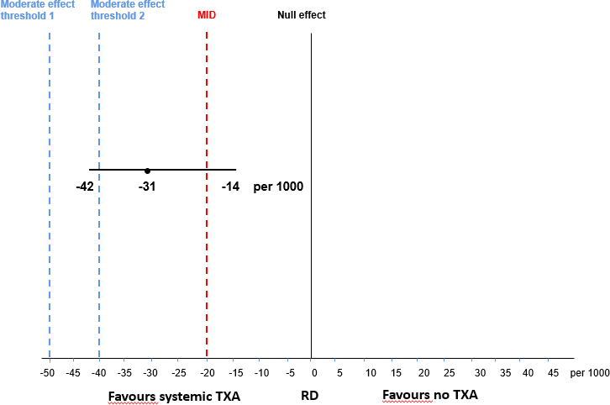

Consider another systematic review of cooling for newborns with hypoxic ischaemic encephalopathy.³ A meta-analysis of randomized controlled trials showed that therapeutic hypothermia yielded 151 fewer deaths or major neurodevelopmental disability per 1000 patients with a confidence interval from 203 fewer to 99 fewer per 1000. Had the review authors been interested in whether a large effect exists, they would rate certainty in relation to a large effect threshold. Considering the importance of the combined outcome (death or major neurodevelopmental disability), had the authors set the large effect threshold at a difference of 80 per 1000, they would rate their certainty that therapeutic hypothermia has a large effect. As the entire CI represents a large effect, they would not rate down for imprecision.
Figure 2. Effect of therapeutic hypothermia versus no therapeutic hypothermia on death or major neurodevelopmental disability in newborns with hypoxic ischaemic encephalopathy.
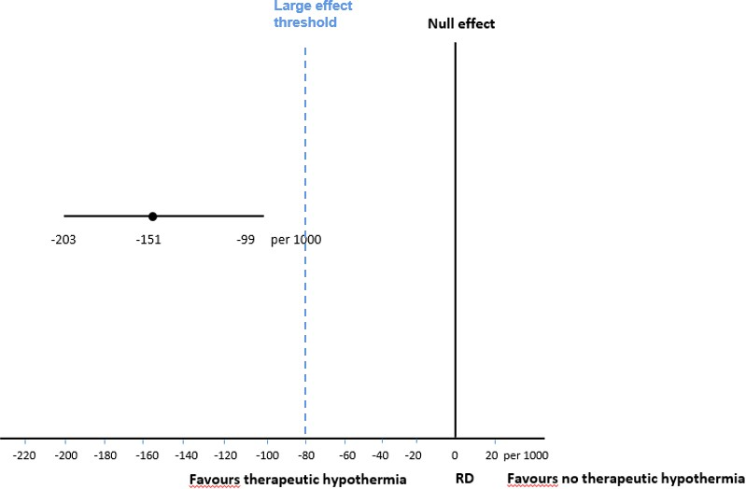

References
- Schünemann HJ, Neumann I, Hultcrantz M, et al. GRADE guidance 35: update on rating imprecision for assessing contextualized certainty of evidence and making decisions. J Clin Epidemiol 2022;150:225-
42. doi: 10.1016/j.jclinepi.2022.07.015 [published Online First: 20220805]
- Cleveland B, Norling B, Wang H, et al. Tranexamic acid for percutaneous nephrolithotomy. Cochrane Database Syst Rev 2023;10(10):Cd015122. doi: 10.1002/14651858.CD015122.pub2 [published Online First: 20231026]
- Jacobs SE, Berg M, Hunt R, et al. Cooling for newborns with hypoxic ischaemic encephalopathy. Cochrane Database Syst Rev 2013;2013(1):Cd003311. doi: 10.1002/14651858.CD003311.pub3 [published Online First: 20130131]

